**Deliverable 7**

What we have working so far for the project is:

* Database
  + Prereq: Holds prerequisites needed to take other classes
    - Prereq ID
    - Course_ID
    - Prev Course ID
  + Previous_course:Holds class taken before
    - Prev ID
    - Course_ID
    - Prev Course ID
    - GPA
    - Term
  + Current_course – Stores all current
    - Current Course ID
    - Course_ID
    - Student ID
    - GPA
    - Term
  + Professor: Holds professor info
    - ID Number
    - First Name
    - Last Name
    - Email
    - Phone number
  + Student: Holds student info
    - Student ID
    - First name
    - Last name
    - Email
    - Phone number
    - GPA
    - Credits
  + Course: Holds Class info: to be used to show student’s class schedule and available classes.
    - Course ID
    - Course Num
    - Subject
    - Course Name
    - Room Number
    - Professor Last Name
    - Date & time
    - Credits
    - Current_Enroll
    - Max_Enroll
  + User_info: Holds user login info.
    - ID number
    - Username
    - Password
    - Account Type
* Java code
  + Connects the GUI to the database
  + Coded the login to allow sign securely.
* Welcome Screen
  + Layout & Design
  + Takes you to login screen.
* Login Screen
  + Layout & Design
  + Verifies that the user exists.
  + Verifies user’s password.
  + Password encryption
  + Takes you the home screen if both credentials are verified.
* Admin Home Screen
  + Create User
  + Create Class
  + Edit User
  + Edit Class
* Edit Class
  + Search for the class you want using ID or name
  + Select field to edit.
  + Delete entire class if needed
* Edit User
  + Drop down menu to select user type: Student or Professor.
  + Search for the class you want using ID or name
  + Select field to edit
  + Delete user if needed.
* Add Class
  + ID
  + Course Number
  + Subject
  + Name
  + Room
  + Professor
  + Days
  + Start Time
  + End Time
  + Start Date
  + End Date
  + Credits
* Add User
  + Dropdown menu to select
    - Student
      * ID Number
      * First Name
      * Last Name
      * Username
      * Password
      * Email
      * Phone Number
      * GPA
      * Credits
    - Professor
      * ID Number
      * First Name
      * Last Name
      * Email
      * Phone Number
* Student Home Screen
  + Layout & Design
  + Add Class
  + Drop Class
  + Logout
* Class Search Screen
  + Layout & Design
  + Search by ID number or Name
  + Add Class to schedule
  + Return to Home screen
  + Logout

What will be shown in the demo video is down below. Along with the database.

## **Scenario #1**

* Student opens app on the welcome page.



* Student navigates to the Login Screen.

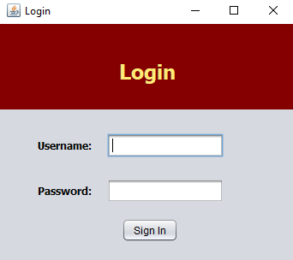

* Student enters incorrect username & Password.

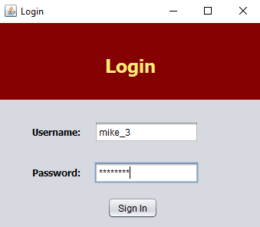

* Error message is displayed stating that incorrect password or username was entered.

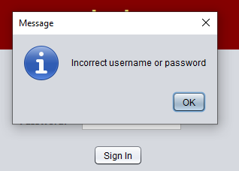

## **Scenario #2**

* Student starts at the login screen.



* Student enters correct username & password.

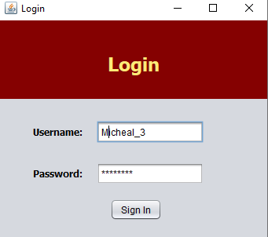

* Student is taken to the home screen where they can take several different actions.

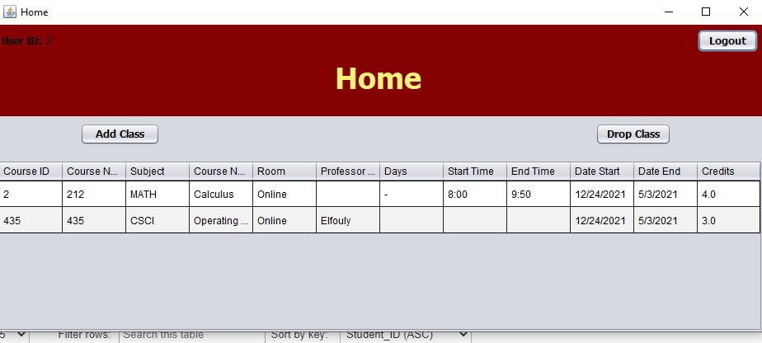

* Student tries to drop class without selecting a class.

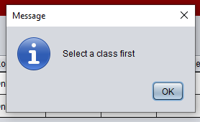

* Student selects class to drop. Drops class successfully.

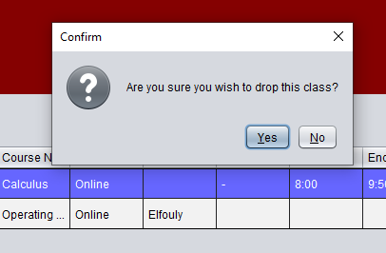

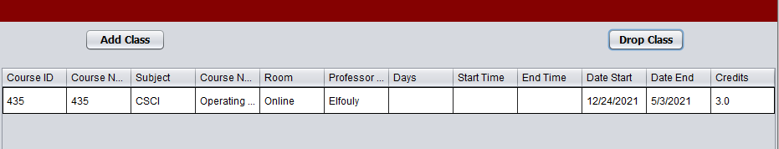

* Student searches class to add

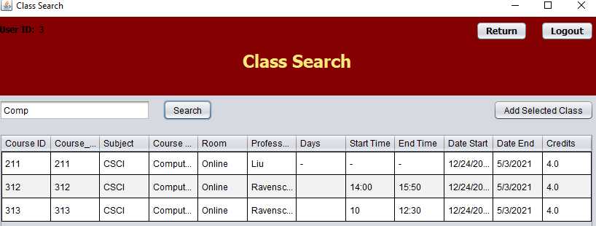

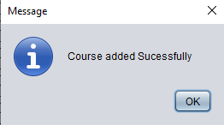

* Student tries to add more classes than allowed.

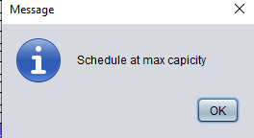

* Student logs out using logout button or use return button to go to home screen.

## **Scenario #3**

* Admin starts at welcome page.



* Admin navigates to login page.



* Admin enters correct username & password.

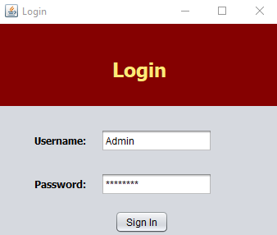

* Admin is taken to homepage. Where they can take several different actions.

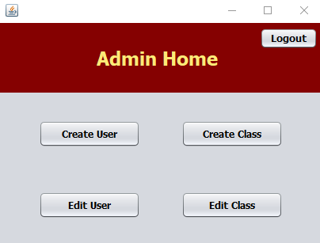

* Admin creates new user. Selects to create new student account. Hits submit button.

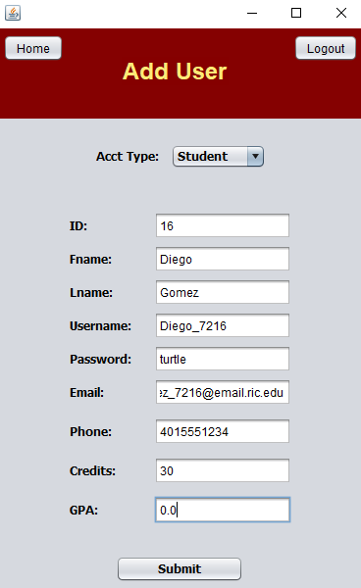

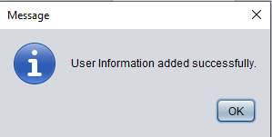

* Admin creates new user. Selects to create new professor account. Hits submit button.

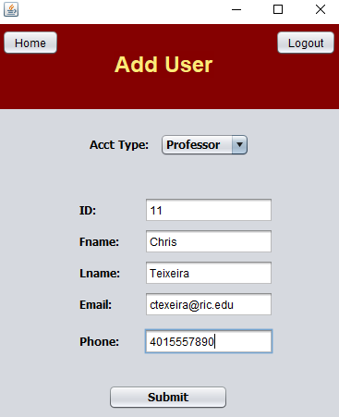



* Admin returns to the home screen. Clicks on Create Class

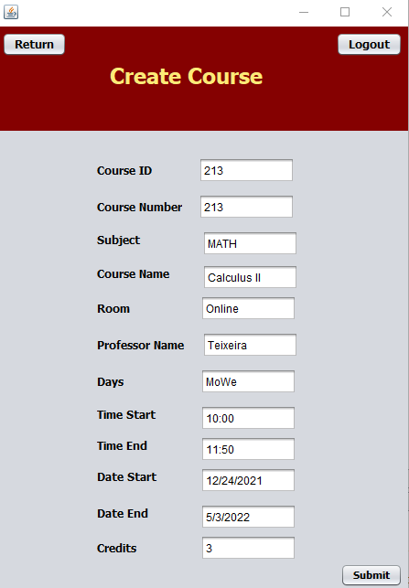

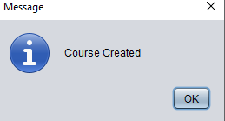

* Admin navigates to home screen. Then goes to edit user.

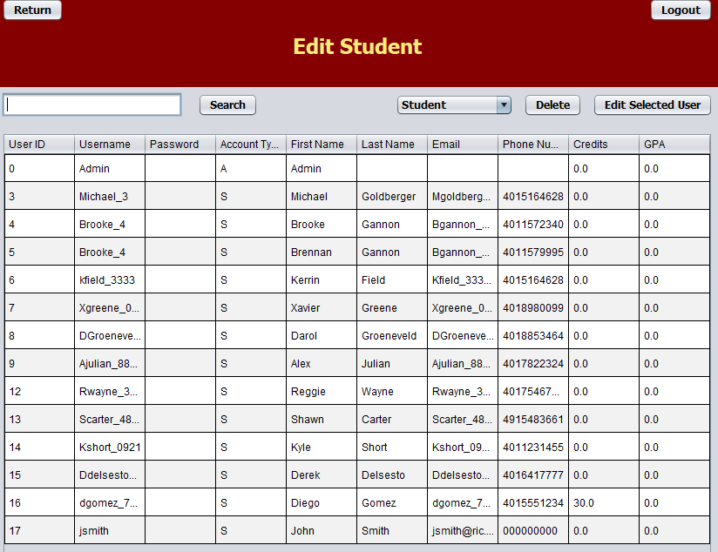

* From edit user. They can use the search bar find a certain user. To delete a user select a user and press the delete button.

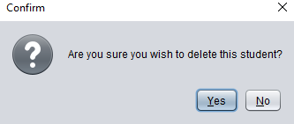

* Edit a user by selecting one of the boxes. Then clicking edit selected user to save the changes.



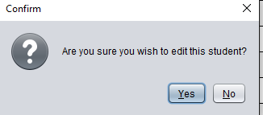

* Admin Navigates home and clicks on edit course. Admin can search the for the class they want to edit by the ID number or name.

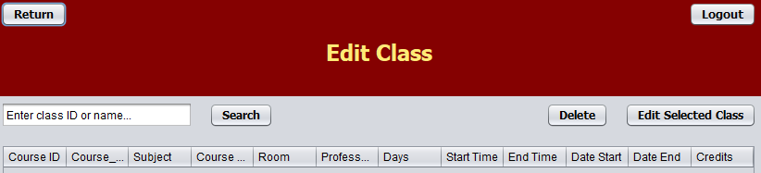

* Once the admin has found the desired class, they can edit the class or delete it entirely.

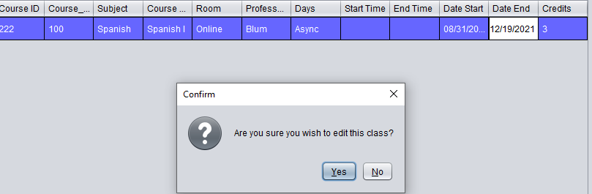

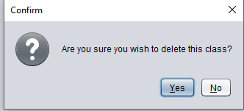

* Database: user_info

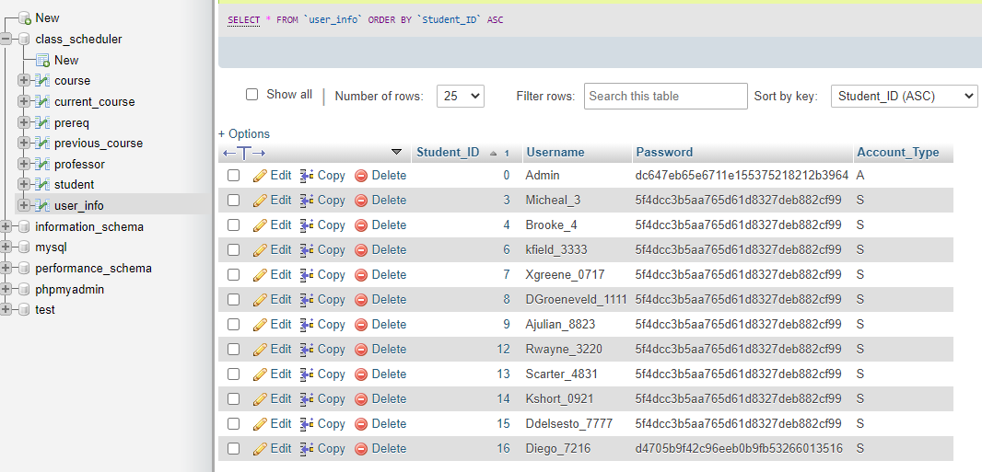

* Database: Student

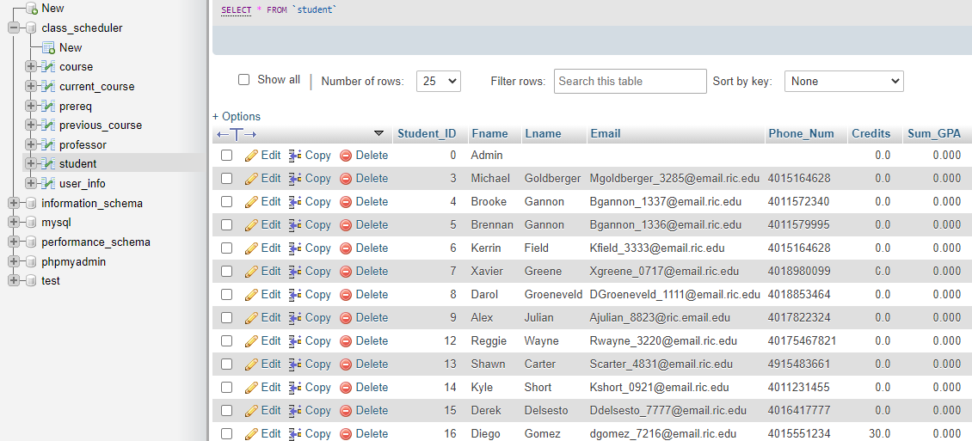

* Database: Professor

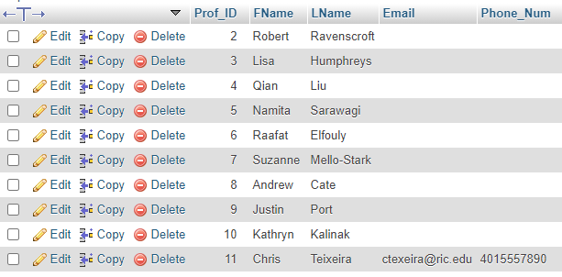

* Database: Course

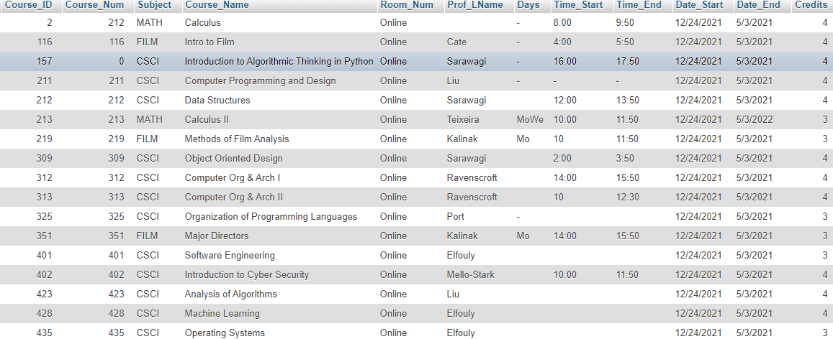

* Database: Schedule

